Name: A.Lakshmi Likitha Course Code: ITA0330
Reg No: 1929472132 Course Name: Mobile Computing
Slot: D

Experiment 1: Basic Cellular System Diagram in Figma

Aim: To create a diagram illustrating the components of a basic cellular system using Figma.

Procedure:
- Open Figma and create a new design file.
- Add a title, “Basic Cellular System”.
- Draw rectangles for Mobile Station (MS), Base Station Subsystem (BSS), Network Switching Subsystem (NSS), and External Networks.
- Add labels and simple icons to each component.
- Connect the components using arrows to show communication flow.
- Apply different colors and arrange the components neatly.

Output:
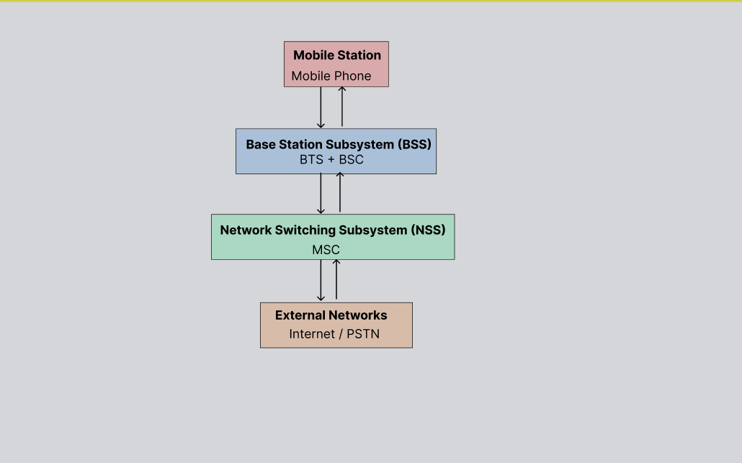


Result: A basic cellular system diagram was created successfully using Figma.

